

EHA300 | Network Adapter

EdgeHandler Adapter (EHA300) is a network adapter which is connected to the target device such as HDMI output device, PC, DVR, NVR and I/O devices. It can convey mouse, keyboard and control information and transmit video through IP network remotely. With EdgeHandler Decoder (EHD200), remote video devices can be controlled.

Tech Notes

Backdoor Issue free
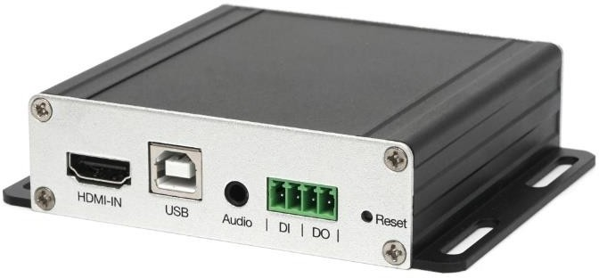
- Non Hi-Silicon

Easy Integration of other vendors DVR, NVR, VMS
- If the video output format of DVR system is admitted to EdgeHandler™ Adapter, most of systems are managed remotely.

Real-time streaming of HDMI Video
- various Video compression standard support (H.265/H.264/MJPEG)
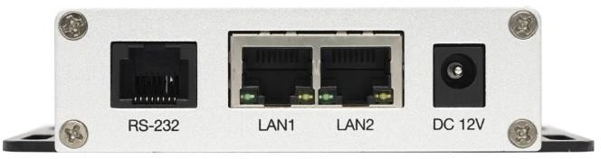
- The fastest proprietary streaming Engine embedd
(Selectable Video Bandwidth, Selectable Video Quality / Resolution)

No additional Software installation needed
- No dependency of operating system (Windows/Linux/MAC)
- Supports any PC/Embedded H/W Irrelevant to Virus infection of HDMI output device
- No impact on the system performance of HDMI output device

Applications -POS Surveillance System
- Ideal for small to mid-sized retail managers and store owners
- Monitor IP surveillance cameras, DVRs for suspicious events

IP Camera interface available with Decoder
- Real-time monitoring by registering IP Cameras Any DVR/NVR can be monitored and controlled by using Adaptor

Easy Integration of any PC system
- PC can be controlled remotely seeing the video screen in real-time



EHA300 | Technical Specifications

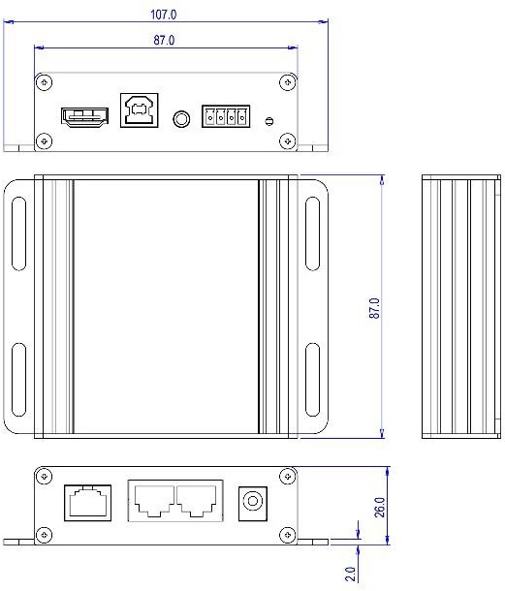

Key Features of EdgeHandler
Real-time streaming of HDMI video
Perfect Mouse Synchronization, Keyboard and Mouse Controllability Multiple streaming & resolution
Power Cycling and Audio, etc. (to be supported)
Possible to turn ON/OFF Power using relay port remotely Two way audio communication (Optional)
Applications : Unmanned facility, Remote system etc.
Video
Max. Streaming Rate | Up to 60fps @ Full-HD  Triple Streaming
Supported Codec | H.264 / H.265 (Option), M-JPEG
Connections | Up to Four connections from EHD200
Interface
Video Out | 1 HDMI  1080p60p, 720p60p, 1280x1024, 1024x768
Audio In/Out | 1 Port (MIC/SPK)
Alarm | 1 DI / 1DO
Serial Port | 1 Serial Port (reserved for future)
Peripherals | 1 USB Port (B type)
Hardware
Approvals | KC, FCC, CE, RoHS
Working Condition | 0℃ ~ +50℃, ~80% RH
Power Supply | SMPS, DC 12V @1A
Power Consumption | Max. 3.5W
Dimension | 107(W) x 83(D) x 26(H) mm
Weight | About 165g without Power Supply

